Chapter 2 IoT Architecture

Drivers Behind New Network Architectures

The key difference between IT and IoT is the data.While IT systems are mostly concerned with reliable and continuoussupport of business applications such as email, web, databases, CRMsystems, and so on, IoT is all about the data generated by sensors andhow that data is used.The essence of IoT architectures thus involves how the data istransported, collected, analyzed, and ultimately acted upon.

The IoT Architectural Drivers–

Scale
Security
Device and networks constrained by power
CPU, memory and link
The massive volume of data generated
Support for legacy devices
The need for data to be analyzed in real time

Scale

The scale of a typical IT network is on the order of several thousand devices—typically printers, mobile wireless devices, laptops, servers, and so on.The traditional three-layer campus networking model, supporting access,distribution, and core (with subarchitectures for WAN, Wi-Fi, data center,etc.), is well understood.But now consider what happens when the scale of a network goes from afew thousand endpoints to a few million. This kind of scale has only previously been seen by the Tier 1 service providers.IoT introduces a model where an average-sized utility, factory, transportation system, or city could easily be asked to support a network of this scale.Based on scale requirements of this order, IPv6 is the natural foundation for the IoT network layer.

Security

One of the example is, targeted malicious attacks using vulnerabilities innetworked machines, such as the outbreak of the Stuxnet worm, which specifically affected Siemens programmable logic controller (PLC) systems.The frequency and impact of cyber attacks in recent years has increased dramatically.Protecting corporate data from intrusion and theft is one of the mainfunctions of the IT department.IT departments go to great lengths to protect servers, applications, and the network, setting up defense-in-depth models with layers of security designed to protect the cyber crown jewels of the corporation.However, despite all the efforts mustered to protect networks and data, the hackers still find ways to penetrate trusted networks.

Refer notes ch2 by dr sasikala

https://www.coursehero.com/file/40674092/Ch-02pptx/

The IoT World Forum (IoTWF) Standardized Architecture :Layer 1-7

The discussion will be based on the seven layer architecture suggested by the Internet of Things World Forum Steering Committee which is widely becoming popular according to current trends.

L1 layer (Physical Devices and Controllers)
The L1 layer consists of physical devices and controllers that might control multiple devices. These are referred to as “Things” in IoT and they include of a wide range of devices that sends and receive information. This information will include the status of the device and information detected by the sensors, which is processed by a local controller and given for transmission using NFC. IoT devices that are connected in the network are capable of A to D (Analog to digital) conversion when required. These can generate data and can be queried or controlled over the net.

L2 layer (Connectivity)
L2 layer relays information between devices, across different networks and between L2 and lower layer of L3. The important functions of L2 are:
- Communication between L1 devices.
- Reliable delivery across the network(s)
- Implementation of different protocols supported by the device
- Switching and routing
- Translation between protocols
- Security at the network level
- (Self-Learning) Networking Analytics
The device would be connected to internet using Wifi, Ethernet, 3G and other technologies. This Connectivity layer enables the device to send data to cloud and vice versa.

L3 layer (Edge Computing)
The ‘Edge computing’ layer formats the data into information that can be understood by L4 layer. The important function of L3 layer are:
- Data filtering, clean-up, aggregation & Validation evaluate if it is ok to be processed by L4.
- Formatting: Reformatting data for consistent higher-level processing
- Expanding/decoding
- Distillation/reduction: Compressing data to minimize the impact of data and traffic on the network and higher-level processing systems
- Assessment: Event generation in case of any alerts.
In short, Edge computing layer formats the data to save in a database. It also receives the data from internet and does filtering and normalization operations.

L4 layer (Data Accumulation)
As the sensor data keeps changing with time, L4 layer converts this data in motion to data in rest. Data accumulation layer stores the data in an easy accessible format. The layer dramatically reduces data through filtering and selective storing.

L5 layer (Data Abstraction)
Data abstraction layer or L5 layer takes the essential data that satisfies certain characteristics from the stored data and supplies it to the application layer for processing. The layer focuses on rendering data and its storage in ways that enable developing simpler, performance-enhanced applications.

L6 layer (Application)
Application layer or L6 layer processes data so that it will be accessible for every person or device to coordinate with the activities. It links the software layer with physical layer. This layer interprets data to generate reports for analytics and to apply business intelligence.

L7 layer ( Collaboration and Processes)
L7 or Collaboration and processes layer provides response or action to be taken against the data provided. This action, for instance can even be an actuation of an electromechanical device upon the instruction from the controller.
https://www.wemakeiot.com/internet-things-iot-architecture/

IT and OT Responsibilities in the IoT Reference Model

1 Introduction

The first major contribution of the IoT Architectural Reference Model (IoT ARM) is the IoT Reference Model itself. Besides models, the IoT Reference Model provides the concepts and definitions on which IoT architectures can be built.

IoT functional model – refer book ebook 1

The Core IoT Functional Stack

The IoT technology stack is nothing else than a range of technologies, standards and tools, which lead from the simple connection of objects to the applications that use these connected things, the data they gather and communicate and the different steps needed to power them.

https://www.i-scoop.eu/internet-of-things-iot/iot-technology-stack-devices-gateways-platforms/

This Thing Stack consists of three technology layers: sensors, microcontrollers and internet connectivity, and service platforms.
- Layer One - Sensors are embedded in objects or the physical environment to capture information and events for your company.
- Layer Two - Microcontrollers and internet connectivity share information captured by sensors within your IoT objects and act based on this information to change the environment.
- Layer Three - Through the aggregation and analysis of data, service platforms cater to your customers. Service platforms also control your IoT product's end-to-end experience and enable your customers to define system rules and update firmwar

Layer 1: Sensors

Sensors have been used for years in a number of different industry contexts like healthcare, aviation, manufacturing and automotive. Now, sensors are so tiny and inexpensive they can be embedded in all the devices you use personally and professionally. The sensor layer of the IoT tech stack continues to expand as internet connected sensors are added to new products and services.
Besides incorporating sensors into your smartphones and tablets, your innovative competitors are introducing new devices that contain numerous sensors. These sensors don't need to be connected directly to the internet and they sync with your smartphone via Bluetooth LE to send captured data to the cloud. For example, Sensordrone is a Kickstarter project that embeds many environmental sensors into a small dongle. Some of the environmental sensors include color intensity, humidity, gas, and pressure sensors. The dongle collects information about your physical environment and sends this information to your smartphone or tablet via Bluetooth. This example demonstrates how value can be created by new services that use sensors to gather new types of data from your physical environment.
Another category of sensors are embedded in watches, contact lenses, wristbands, and fabrics. Recently, Nokia patented a technique for magnetic tattoos that vibrate from incoming messages or calls. This is possible by spray tattooing or stamping a material onto your skin. The material is then paired with a smartphone or tablet, which lets you interact with the sensor. Microsoft and University of Washington researchers are working on another way to connect sensors to your body through the use of IoT contact lenses that provide real-time updates about the biochemical fluctuations in your body. One use case is to help diabetes patients monitor their insulin levels while using these contact lenses.

Layer 2: Micro-controllers and internet connectivity

The second layer in the Internet of Things technology stack allows for local storage, data processing and internet connectivity. The Internet of Things needs internet connectivity to send collected data to your cloud database. Because some sensors generate over 10,000 data points per second, it makes sense to pre-process data locally before sending it to your cloud database. By analyzing, extracting and summarizing your collected data before you send it to your cloud database, you reduce the volume of unnecessary data you send to and store on your cloud database, saving you money on data transfer and storage costs.
Your microcontroller is a small computer embedded within a chip and it helps your IoT device store and pre-process collected data before it's synced to your cloud database. Your microcontroller possesses a processor, a small amount of RAM to hold data, some kilobytes of EPROM or flash memory to hold embedded software, and solid-date memory to cache data.
In some cases, your IoT device may need to use programmable microcontrollers to take action and turn something on or off. In most cases, these decisions are made via a cloud application, but it makes sense to use programmable microcontrollers when a sensor detects something that could affect the health and safety of your end customers.
The main and most important capability of this layer is networking, which is either wireless or wired. If a device is stationary and can access an external power source, a wired network is sufficient, but a wired network doesn't make sense for many IoT use cases because physical cables are needed to connect to the network. WiFi, wireless modems, and wireless mesh networks are the most common ways IoT devices are connected to the internet.
If you plan to manufacture an IoT device you must keep in mind dependencies for your use cases. Is your device mobile or fixed? Does your device need a battery or is it connected to a fixed power supply? How much data do you need to transfer to your cloud database per hour? Should your device's connectivity be episodic or continuous?
Devices you use to track your health and fitness while bicycling, running, and exercising store data while you're active, and these devices use episodic connectivity. Your device then syncs with the cloud when it's close to your smartphone or tablet. Compare this to the continuous connectivity needed by Amazon Echo's voice based digital assistant who is always listening for your commands, fetching answers from the internet the instant you ask a question. Depending on your IoT product's use cases, you may need continuous connectivity.
When you research Think Stack vendors, you'll notice a wide range of different networking protocols, hardware, software, and architectures are used to build IoT products. Due to the variation in use cases and environments, you have many choices when it comes to adding networking and computing capabilities your IoT device. While some vendors focus more on hardware components, other vendors provide a system of integrated software and hardware. Sometimes, IoT software solutions spill into the third layer of the Thing Stack, which is referred to as the service platform.

Layer 3: Service platforms
The first two layers for the Thing Stack embed sensor and microcomputers in your IoT device, but your IoT product profits from the service platform layer. This layer delivers value to your customers by automating processes and delivering rich data analytics. Your cloud application combines data collected from numerous IoT sensors with your (or your customers) other business data to produce insights that generate business value.
It's important for your service platform to create a feedback loop between your IoT devices and you device management software, so you and your customers can upgrade, monitor, and maintain the firmware on each the device. In most cases, service platforms operate on cloud infrastructure and utilize a multi-tenant software architecture to deliver a seamless software-as-a-service (SaaS) experience.
The convergence between our digital and physical worlds stresses your IT operations by increasing demand for data management, storage, tagging and analysis. It's in your company's best interests to build your IoT service platform on robust cloud infrastructure, so you can scale infinitely as your business grows with your new IoT product.
While "software is eating the world" as Marc Andreessen said, consumers and companies still purchase a lot of physical things. If you build a robust IoT service platform, you obtain insights about how your customers use your IoT products and services. With a great IoT service platform you can manage post-transaction relationships in new and engaging ways.
Because service platforms store and make decisions based on data collected from all types of IoT devices, they are often considered the backbone of post-transactions relationships. What if you reached out to customers who never powered on your IoT device and proactively on-boarded them? What if you used anonymized data from customers getting the most value out of your product to help other customers unlock more business value?
Now is the time to build your IoT product because sensors keep getting smaller and network connectivity solutions keep getting better. Create a plan to engage with your customers and facilitate goal-oriented post-transaction relationships, leading to new opportunities to turn a single transaction into a strong relationship.

https://www.cognitiveclouds.com/insights/the-internet-of-things-iot-tech-stack-explained
Data Analytics in IoT
Internet of Things (IoT) analytics is a data analysis tool that assesses the wide range of data collected from IoT devices. IoT analytics assesses vast quantities of data and produces useful information from it.
IoT analytics are usually discussed in tandem with Industrial IoT (IIoT). Data is collected from a wide range of sensors on manufacturing infrastructure, weather stations, smart meters, delivery trucks, and all forms of machinery. IoT analytics can be applied to managing data centers and applications handling retail and healthcare.
In many ways, IoT data is similar to big data. The key difference between the two is not just the quantity of data but the range of sources it is obtained from. All this data has to be processed into one comprehensible, single stream of data. Considering the several kinds of sources of information, data integration becomes quite difficult, and this is where IoT analytics makes a difference, though it can be tough to develop and implement.

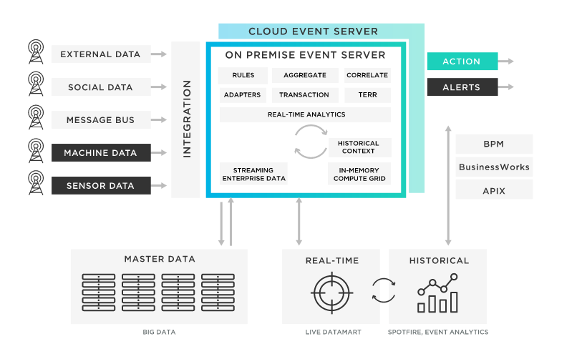

Devices that power IoT Analytics
There are a wide range of IoT devices that collect data:

Wearables
Dedicated trackers such as Fitbit or other smartwatches have gone beyond tracking steps. You can track your friends' fitness activities, compete with them, message, and even answer the phone by connecting your devices through the Internet. This information is tracked by fitness companies, enabling them to create customized packages if you sign up. This can include exercise routines, diet, goals, and more. The newest smart watches even monitor heart rates and rhythms and have accurately diagnosed heart problems in their wearers.

Smart Home
Smart homes have security systems you can access and control when you are away from home, to appliances you can turn on and off with digital assistance. There is a wide range of devices that you can incorporate into your home and a wide range of data that can be collected to assess usage patterns, the efficacy of systems, and more.

Healthcare
Healthcare has a wide range of IoT devices. Bluetooth technology creates hearing aids, records heart and blood pressure, and monitors pulse-based alarm systems that can call for help. This has helped enhance healthcare to a large extent. The data collected is invaluable in terms of creating newer and better technology.

Voice-Activated Everything
Digital assistants are a form of IoT devices. Alexa, Siri, and Google take notes, find information, play music, order cabs, tell the weather, set alarms, and everything else. The internet regularly updates these digital assistants to improve functionality. Their data helps companies tailor their services for you, based on your everyday interaction with digital assistants.

How IoT Analytics Work and the Applications
With a wide range of devices, there is an endless stream of data in enormous quantities. IoT analytics helps analyze this data across all connected devices without hardware or infrastructure. As the needs of your organization change, computing power and data storage scales up or down accordingly, ensuring your IoT analysis has the requisite capacity.
- The first step is to collect data aggregated from a variety of sources, in a range of formats, and at multiple frequencies.
- This data is then processed with a wide range of external sources.
- The information is then stored in a time-series for analysis.
- The analysis can be done in multiple ways--with custom analysis systems, with standard SQL queries, or with machine learning analysis techniques. The results can be used to make a wide range of predictions.
- With the information received, organizations can build several systems and applications to ease business processes.

Business Use Cases of IoT Analytics
Smart agriculture: With IoT analytics, connected field machinery works based on information derived from IoT analysis. Analysis factors include time, geographical location, weather, altitude, and local environmental conditions. For example, irrigation systems can be optimized to deliver the exact amount of water as rainfall predictions.
Regular restocking of supplies: Monitor inventories in real-time. A food vending company, with connected machines, can have their machines request restocking based on the depletion of products. This can be triggered when stocks in the machine reach a particular level.
Predictive maintenance: Varying infrastructure needs regular maintenance. With IoT analysis, pre-set templates can help determine quality predictive maintenance models applied to specific needs. For example, in long-distance transport vehicles with heating and cooling systems--IoT analytics can determine when vehicles need an overhaul to ensure cargos are not damaged.
Process efficiency scoring: Every company works with a range of processes in place. IoT analytics can measure the efficiency of these processes and make the necessary changes in them. Results from IoT analytics can identify bottlenecks--both current and potential--and can increase efficiencies.
https://www.tibco.com/reference-center/what-is-iot-analytics

Benefits of IoT analytics
IoT analytics offer several benefits for businesses that use them:
- Visibility on the entire IoT network – IoT analytics enables businesses to oversee the performance of their IoT network in real-time.
- Fast identification and resolution of problems in business operations – Businesses can use diagnostic analytic capabilities to quickly identify performance problems and use prescriptive analytics to fix such problems.
- Better asset utilization – Businesses can use IoT analytics to monitor the performance of their assets, such as machinery, and tweak their utilization to ensure the long term health of assets.
- Cost optimization – IoT analytics help identify areas of cost reduction and steps to implement to achieve such cost reduction.
- Expansion into new markets – IoT analytics offer valuable insights on operations and consumer behavior to ease expansion into new markets.
- Improved product development – Businesses can study historical trends in product usage by consumers to identify areas of improvement for future versions of their products.
- Better customer experience – IoT analytics helps businesses identify customer problems in real-time and act quickly to fix those problems, thus enhancing customer experience and delight.

IoT Analytics: Challenges
Businesses may face challenges in using IoT analytics tools. Some of these challenges are –
- Excessive data generation and storage requirements –The aggregate data generated by thousands of IoT sensors are usually very large, thus making it expensive to manage and store such data.
- The complexity of data – Data from multiple IoT devices consists of different types, formats and sizes, thus making it very complex and difficult to process and clean.
- Security – Businesses, especially those dealing with consumer data, have to take various security measures to protect the stored IoT network data against hacking attempts and leaks.
- Inaccurate data – Faulty IoT devices lead to inaccurate measurements, thereby messing up the analysis of such data. When you have faulty IoT devices at large, the insights offered by IoT analytics tools become unreliable.
- Building a competent data analysis team – Businesses need to hire data scientists and analysts to run analytical techniques on the IoT data and derive actionable insights.
https://www.airtel.in/blog/business/iot-analytics-benefits-challenges-use-cases/

Network analytics in IoT and Control applications are pending

Cloud Computing

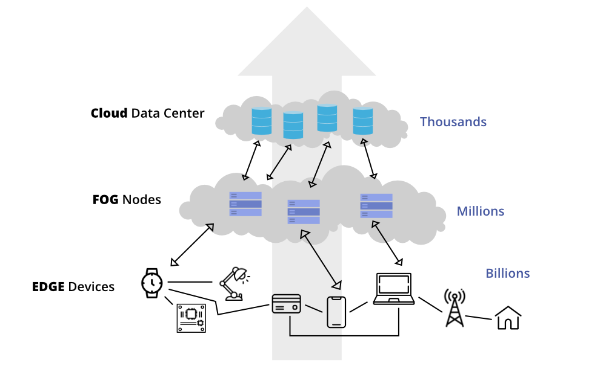
Cloud computing refers to the on-demand delivery of IT services/resources over the internet. On-demand computing service over the internet is nothing but cloud computing. By using cloud computing users can access the services from anywhere whenever they need.
Nowadays, a massive amount of data is generated every second around the globe. Businesses collect and process that data from the people and get analytics to scale their business. When lots of organizations access their data simultaneously on the remote servers in data centers, data traffic might occur. Data traffic can cause some delay in accessing the data, lower bandwidth, etc. But cloud computing technology alone is not effective enough to store and process massive amounts of data and respond quickly.
For example, in the Tesla self-driving car, the sensor constantly monitors certain regions around the car. If it detects an obstacle or pedestrian on its way, then the car must be stopped or move around without hitting. When an obstacle is on its way, the data sent through the sensor must be processed quickly and help the car to detect before it hits. A little delay in detection could be a major issue. To overcome such challenges, edge computing and fog computing are introduced.

Edge Computing
Computation takes place at the edge of a device’s network, which is known as edge computing. That means a computer is connected with the network of the device, which processes the data and sends the data to the cloud in real-time. That computer is known as “edge computer” or “edge node”.
With this technology, data is processed and transmitted to the devices instantly. Yet, edge nodes transmit all the data captured or generated by the device regardless of the importance of the data.
Example of Edge computing:
- Autonomous vehicle edge computing devices collect data from cameras and sensors on the vehicle, process it, and make decisions in milliseconds, such as self-parking cars.
- In order to accurately assess a patient’s condition and foresee treatments, data is processed from a variety of edge devices connected to sensors and monitors.
Here Fog Computing was introduced and becomes an ideal solution.

Fog Computing
Fog computing is an extension of cloud computing. It is a layer in between the edge and the cloud. When edge computers send huge amounts of data to the cloud, fog nodes receive the data and analyze what’s important. Then the fog nodes transfer the important data to the cloud to be stored and delete the unimportant data or keep them with themselves for further analysis. In this way, fog computing saves a lot of space in the cloud and transfers important data quickly.

Fog computing is a decentralized computing infrastructure or process in which computing resources are located between the data source and the cloud or any other data center. Fog computing is a paradigm that provides services to user requests at the edge networks. The devices at the fog layer usually perform operations related to networking such as routers, gateways, bridges, and hubs. Researchers envision these devices to be capable of performing both computational and networking operations, simultaneously. Although these devices are resource-constrained compared to the cloud servers, the geological spread and the decentralized nature help in offering reliable services with coverage over a wide area. Fog computing is the physical location of the devices, which are much closer to the users than the cloud servers.

Difference Between Edge Computing and Fog Computing
S.NO. | EDGE COMPUTING | FOG COMPUTING
01. | Less scalable than fog computing. | Highly scalable when compared to edge computing.
02. | Billions of nodes are present. | Millions of nodes are present.
03. | Nodes are installed far away from the cloud. | Nodes in this computing are installed closer to the cloud(remote database where data is stored).
04. | Edge computing is a subdivision of fog computing. | Fog computing is a subdivision of cloud computing.
05. | The bandwidth requirement is very low. Because data comes from the edge nodes themselves. | The bandwidth requirement is high. Data originating from edge nodes is transferred to the cloud.
06. | Operational cost is higher. | Operational cost is comparatively lower.
07. | High privacy. Attacks on data are very low. | The probability of data attacks is higher.
08. | Edge devices are the inclusion of the IoT devices or client’s network. | Fog is an extended layer of cloud.
09. | The power consumption of nodes is low. | The power consumption of nodes filter important information from the massive amount of data collected from the device and saves it in the filter high.
10. | Edge computing helps devices to get faster results by processing the data simultaneously received from the devices. | Fog computing helps in filtering important information from the massive amount of data collected from the device and saves it in the cloud by sending the filtered data.

https://www.geeksforgeeks.org/difference-between-edge-computing-and-fog-computing/

Feature | Cloud Computing | Fog Computing
Latency | Cloud computing has high latency compared to fog computing | Fog computing has low latency
Capacity | Cloud Computing does not provide any reduction in data while sending or transforming data | Fog Computing reduces the amount of data sent to cloud computing.
Responsiveness | Response time of the system is low. | Response time of the system is high.
Security | Cloud computing has less security compared to Fog Computing | Fog computing has high Security.
Speed | Access speed is high depending on the VM connectivity. | High even more compared to Cloud Computing.
Data Integration | Multiple data sources can be integrated. | Multiple Data sources and devices can be integrated.
Mobility | In cloud computing mobility is Limited. | Mobility is supported in fog computing.
Location Awareness | Partially Supported in Cloud computing. | Supported in fog computing.
Number of Server Nodes | Cloud computing has Few number of server nodes. | Fog computing has Large number of server nodes.
Geographical Distribution | It is centralized. | It is decentralized and distributed.
Location of service | Services provided within the internet. | Services provided at the edge of the local network.
Working environment | Specific data center building with air conditioning systems | Outdoor (streets,base stations, etc.) or indoor (houses, cafes, etc.)
Communication mode | IP network | Wireless communication: WLAN, WiFi, 3G, 4G, ZigBee, etc. or wired communication (part of the IP networks)
Dependence on the quality of core network | Requires strong network core. | Can also work in Weak network core.

https://www.geeksforgeeks.org/difference-between-cloud-computing-and-fog-computing/?ref=rp

